# Table of Contents

1. Introduction
   1. Purpose 2
   2. Product Features 2
2. Hardware Requirements 3
3. Software Requirements 4
4. Structure/Working of Project
   1. Face recognition
   2. Boquet effect 7
   3. Blur effect
   4. Colored filters 9
5. Introduction

Pixala is a multi-feature image processing software in which a user can apply various effects to any image. It supports various features that a user can apply onto the image.

* 1. Purpose

Using Pixala, users can apply various effects on an image. Generally, effects like ‘blur’, ‘boquet’, ‘face-recognition’ require some hardware support which makes the process costly. So, using pixala, users can apply these effects without any hardware support and is thus cost effective.

* 1. Project Features and Functions

The main features of our project include:

1. Face Recognition: This feature uses deep learning to train the face-recognition model. Once trained, the App can detect and recognize any face in the image and add the image to the folders of people whose faces are detected in the image.
2. Boquet Effect: This effect uses edge detection to create a boquet effect in the image. *(Boquet Effect: An effect in which everything except the main item is blurred)*
3. Blur effect: It allows the user to blur the wanted areas of an image using a blur tool.
4. General filters: this is a collection of filters which will be applied to the image.

The collection of filters include filters like:

1. Sepia
2. Cartoon filter
3. Black and white
4. Invert filter

The main function of our project include:

1. Face-recognition
2. Boquet effect
3. Blur effect
4. Color based filters
5. Software Requirements

The software and libraries used in this project are:

1. Python 3.8
2. Jupyter notebook
3. Numpy
4. Matplotlib
5. PIL : python image library
6. OpenCV
7. Face_recognition
8. os
9. Structure/Working of Project

The project is divided into four major components.

. Face_recognition

. Boquet

. Blur

. Filters

* 1. Face recognition:

This feature allows the users to enter an image and recognizes the faces in the image. We also add the image to the user’s folder. The Working of this feature can be explained in two ways :

1. Training Phase: The first phase is the training phase. We use deep learning to train our neural network. We use already known images to train our neural network. The network make an encoding of each image and use it for recognizing this face in other images.

Known images:

// put some known images

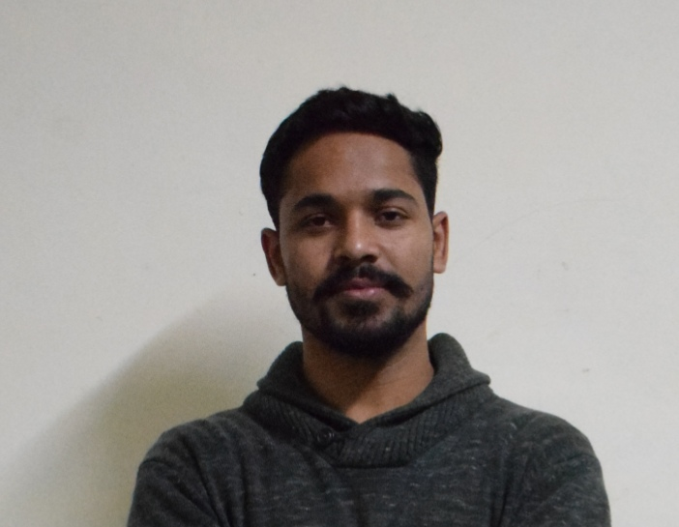

Arvind’s known image



Kashish known image



Rishabh’s known image

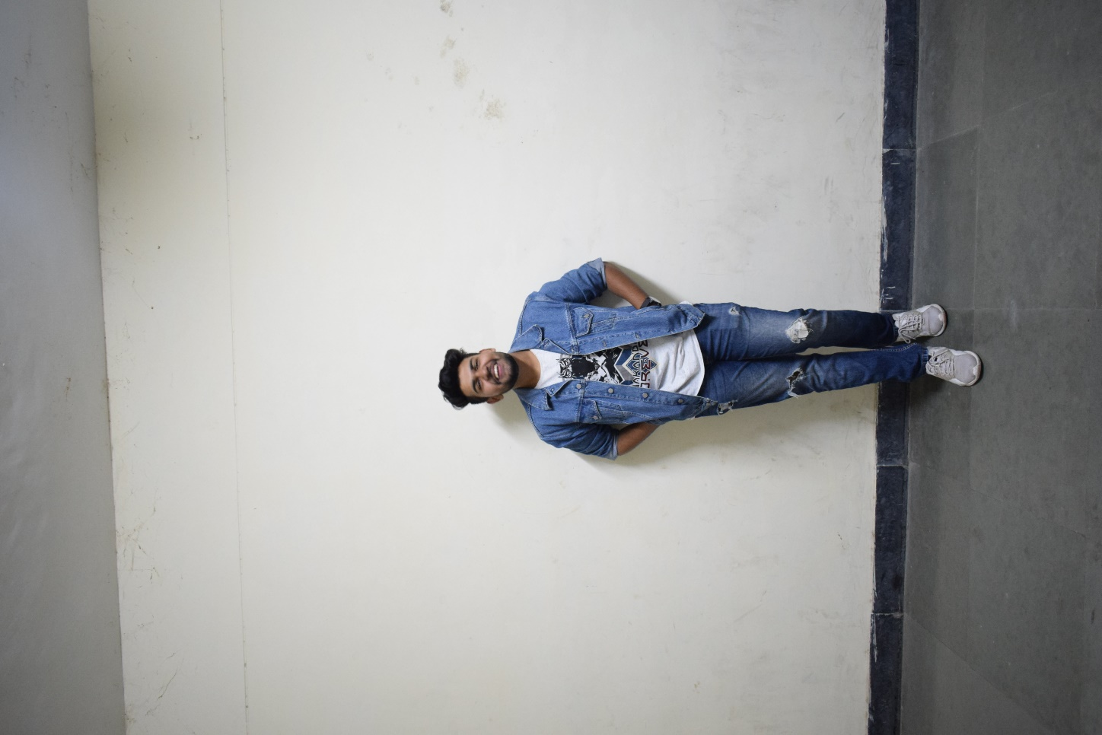

Suryanshu’s known image

1. Testing phase: In this phase, the neural network uses the known face encodings t recognize the faces in unknown images.

Faces being recognized in unknown images:

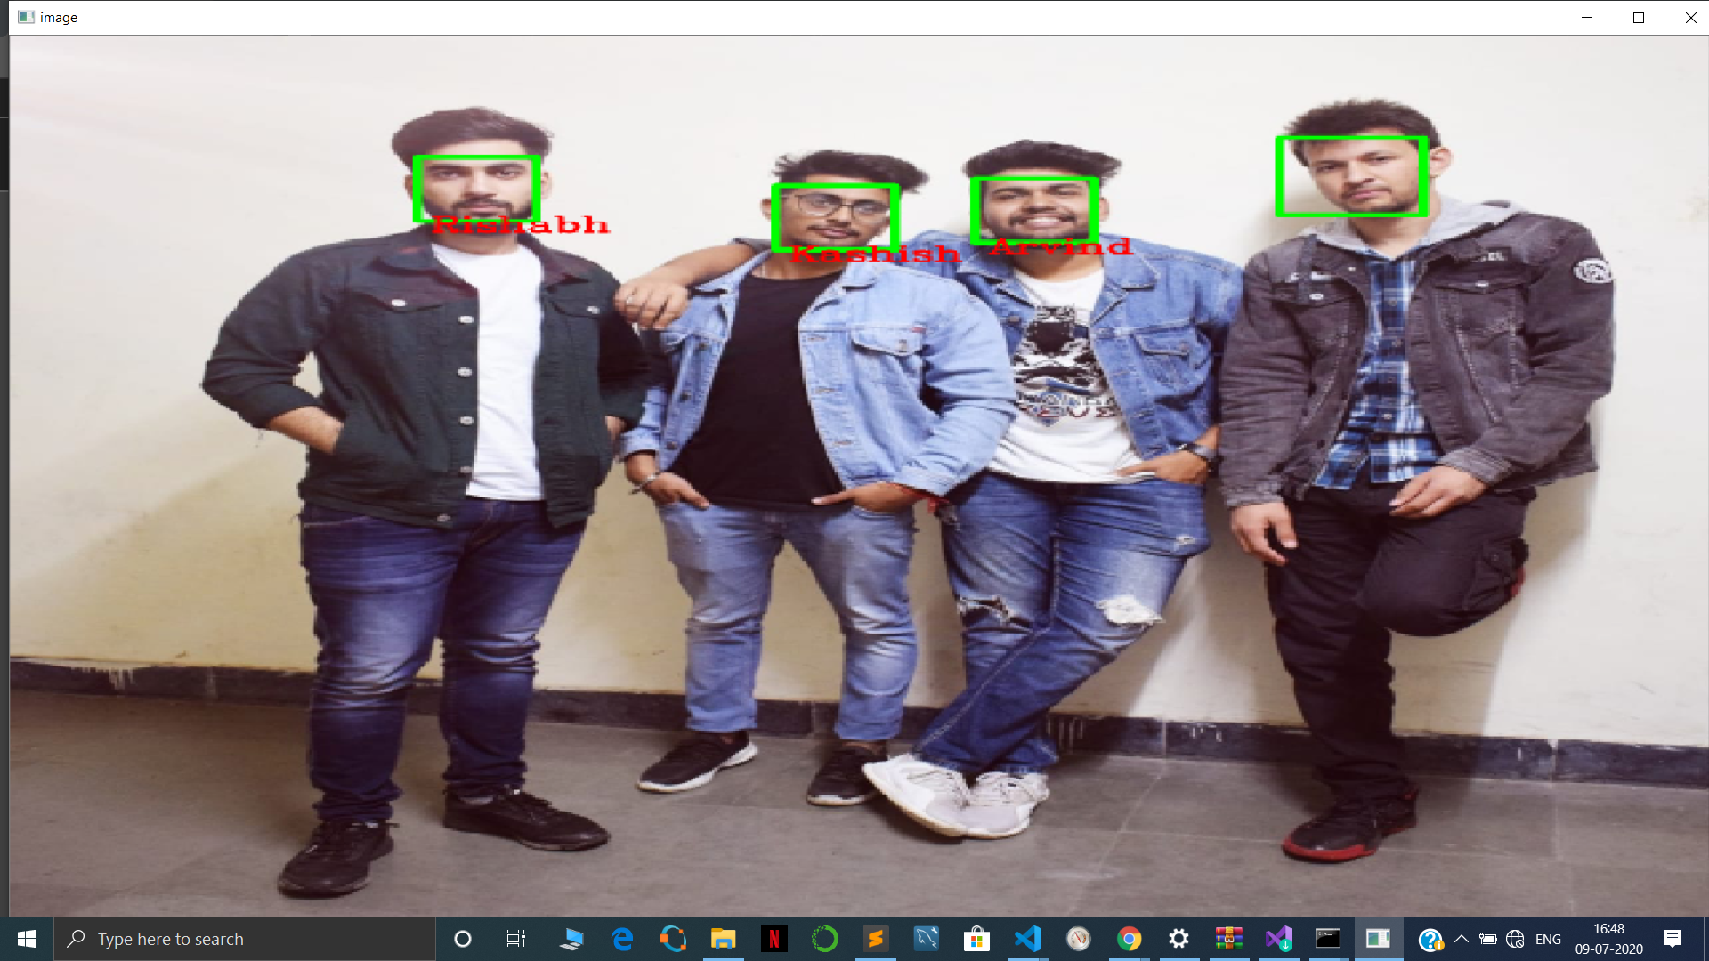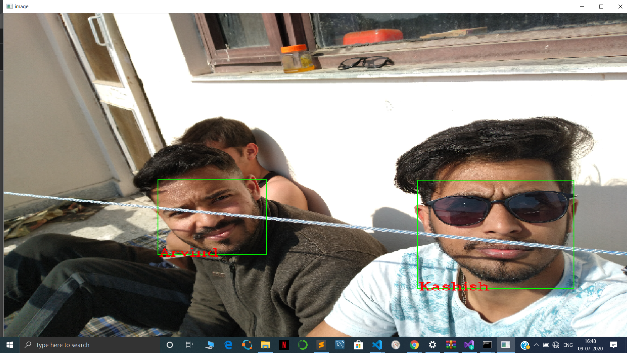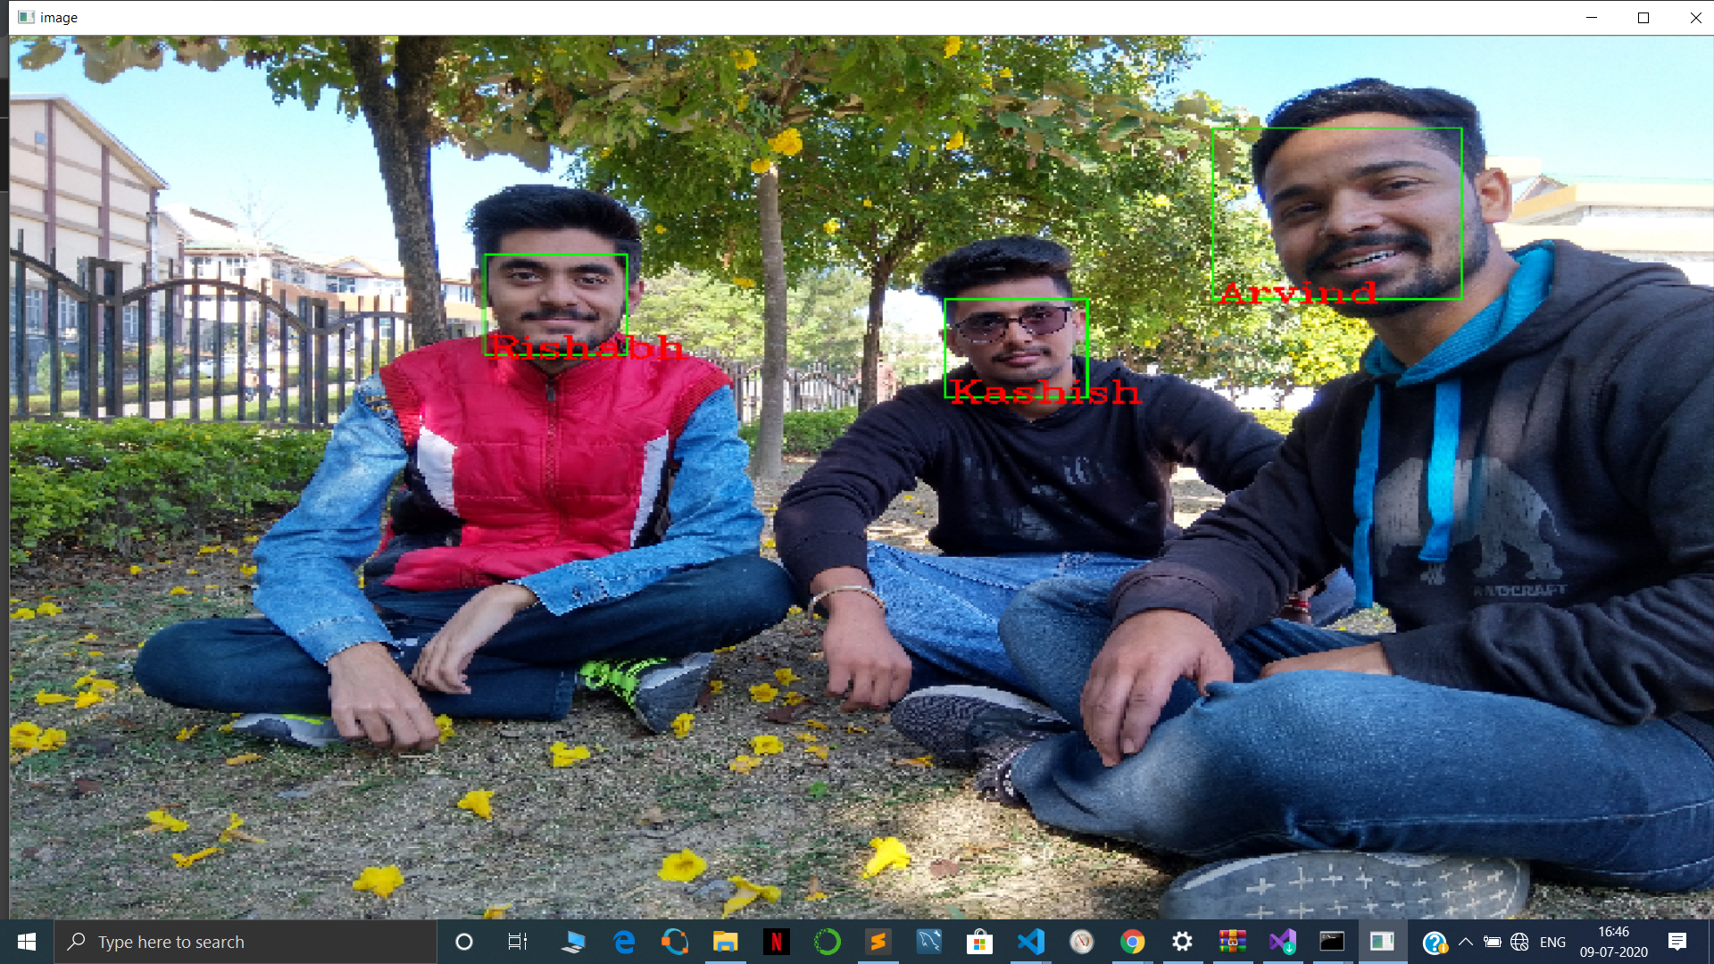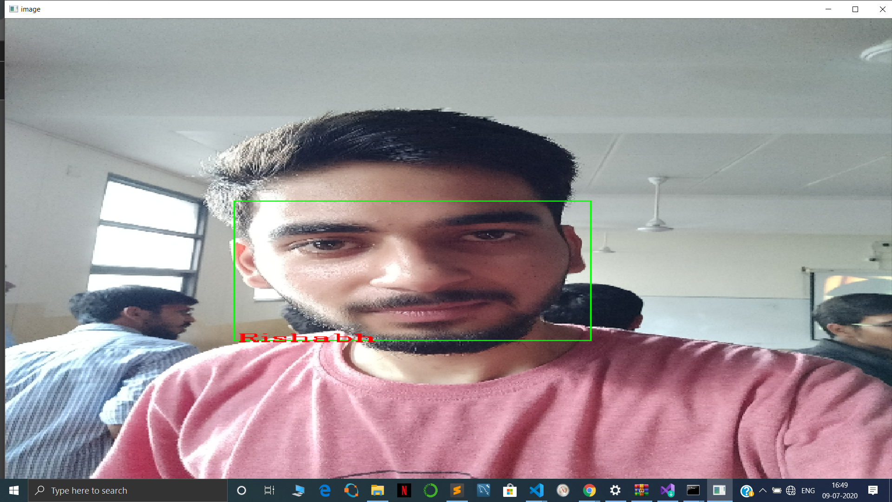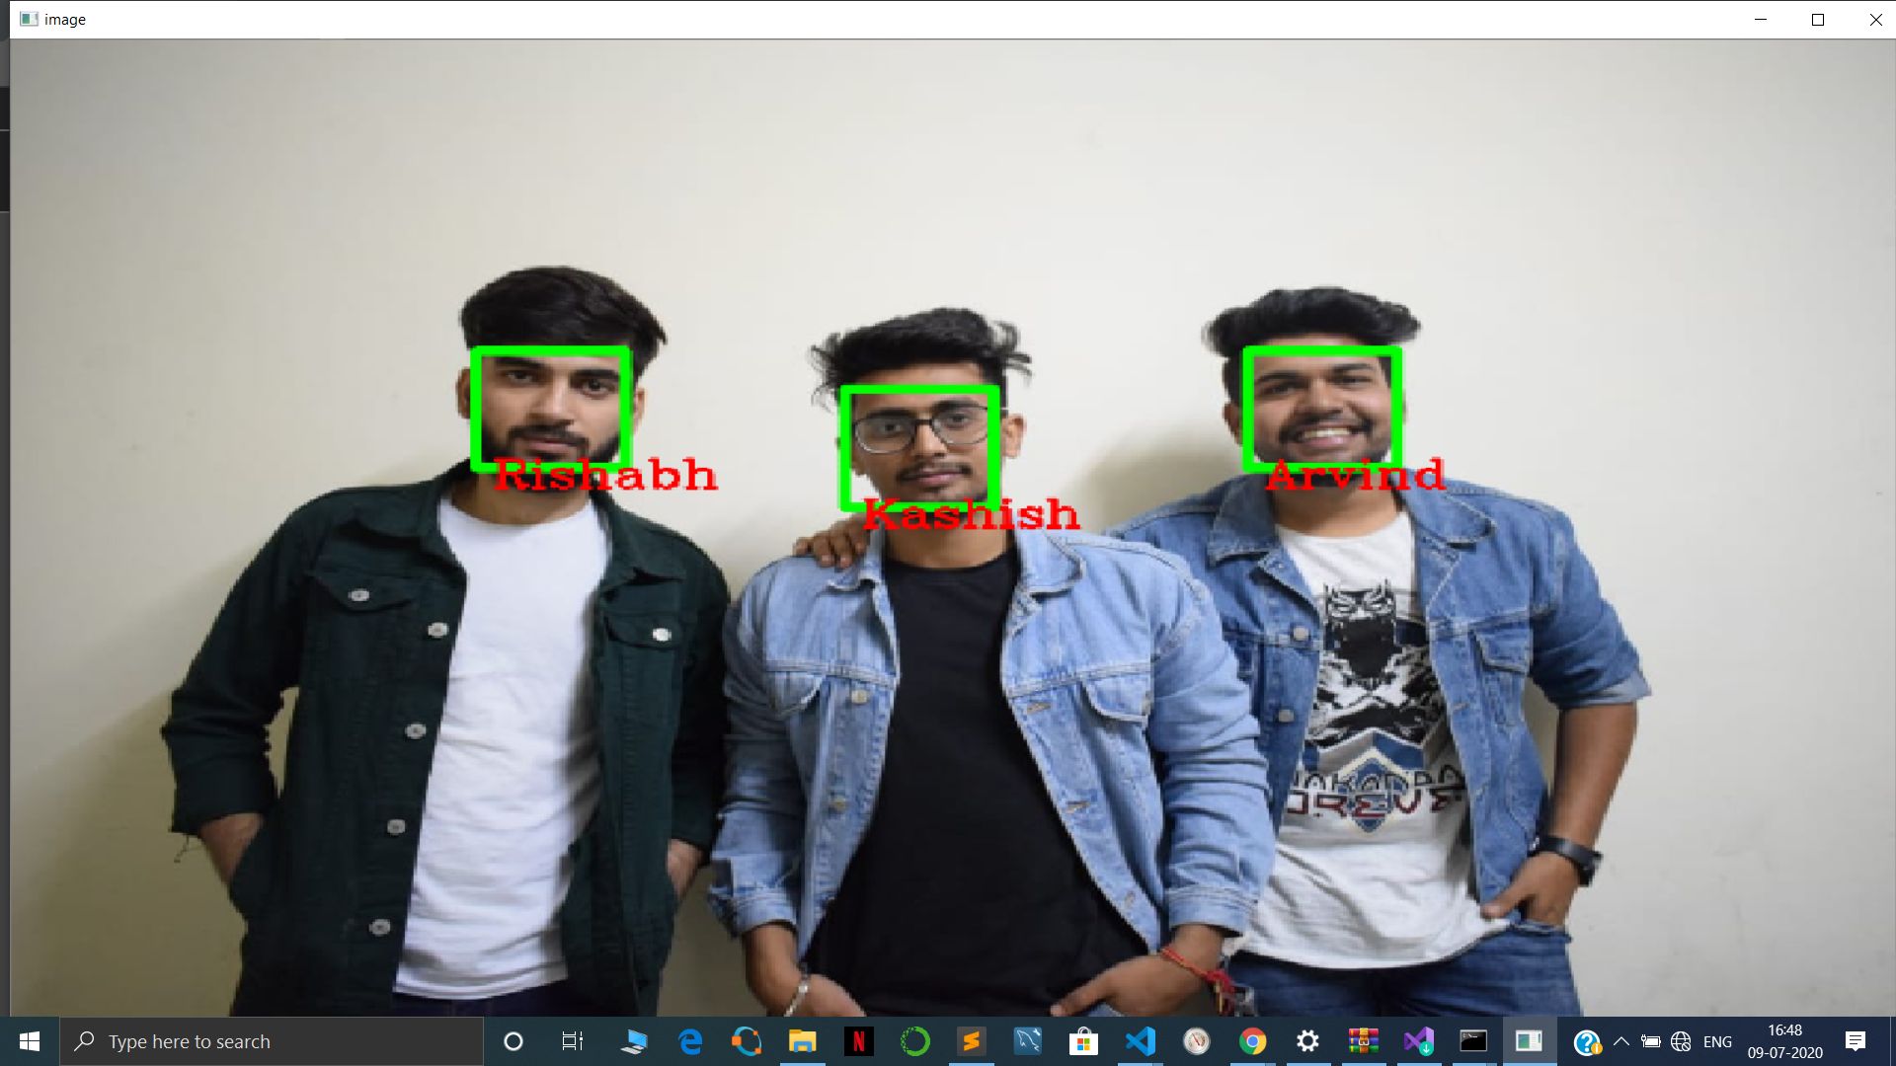

* 1. Boquet Effect : Boquet effect refers to the background blur effect in which the background of an object in the image is blurred out without changing the main object.

The boquet effect is implemented using following steps:

1. Load the original image:

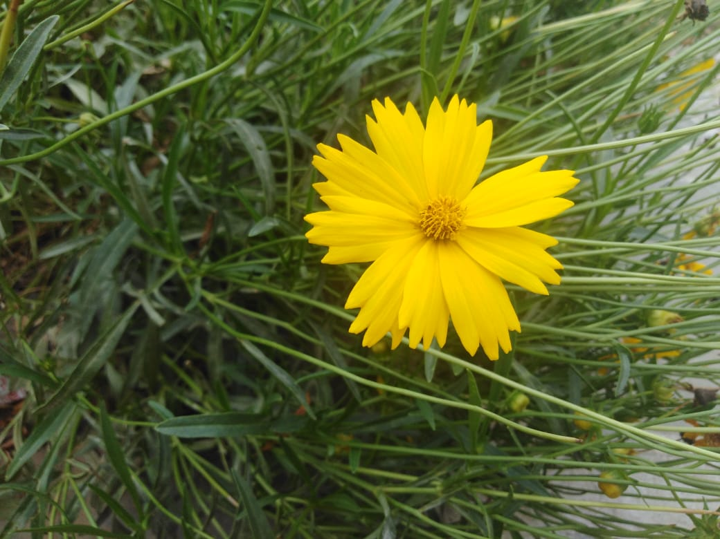

1. We take a copy of the image and blur the copy of the image. Save the blurred image.

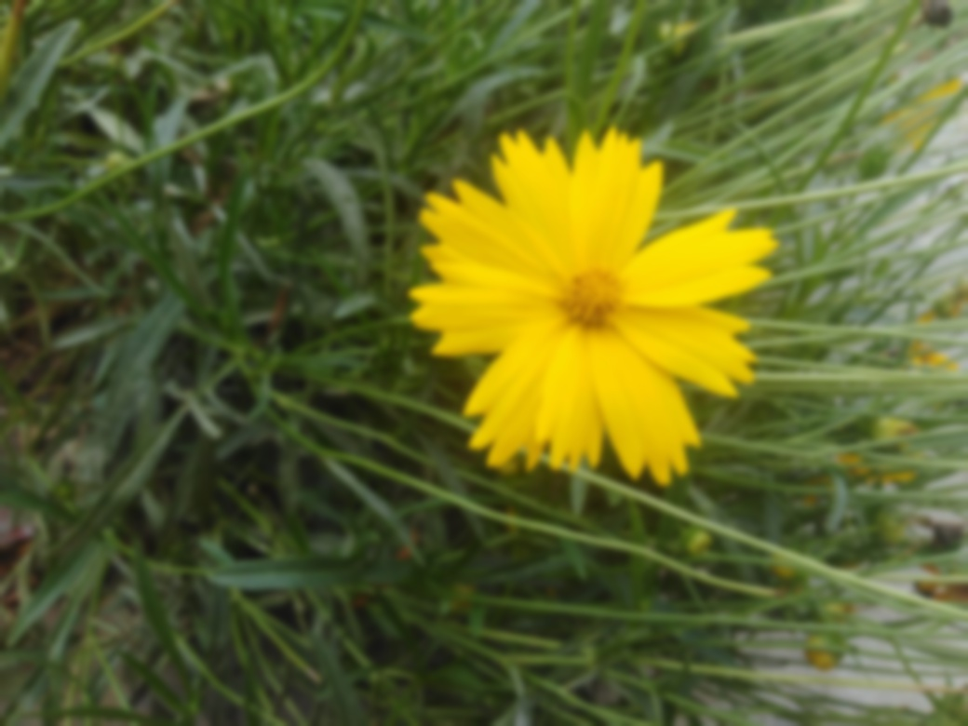

1. Make a mask of the main object in the original image.
2. 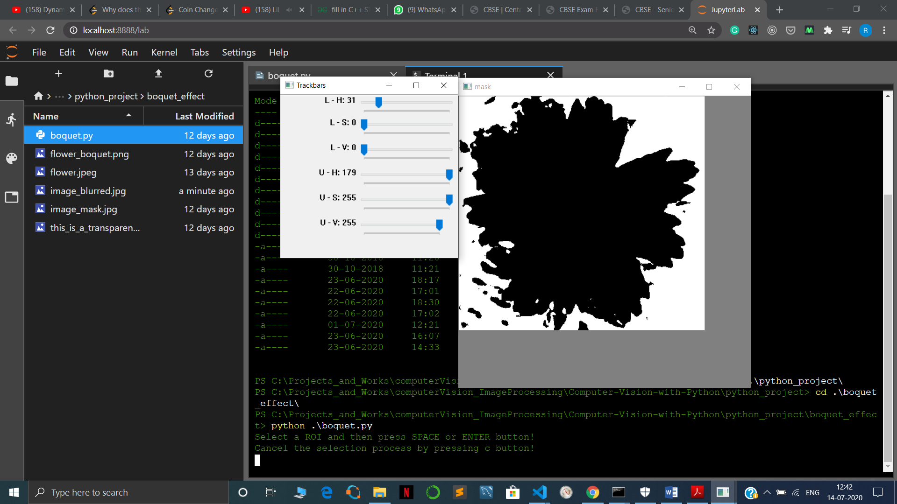
3. Take the bitwise or of the mask and original image:



1. Now Paste the resulting mask on top of the blurred image to produce the boquet effect.

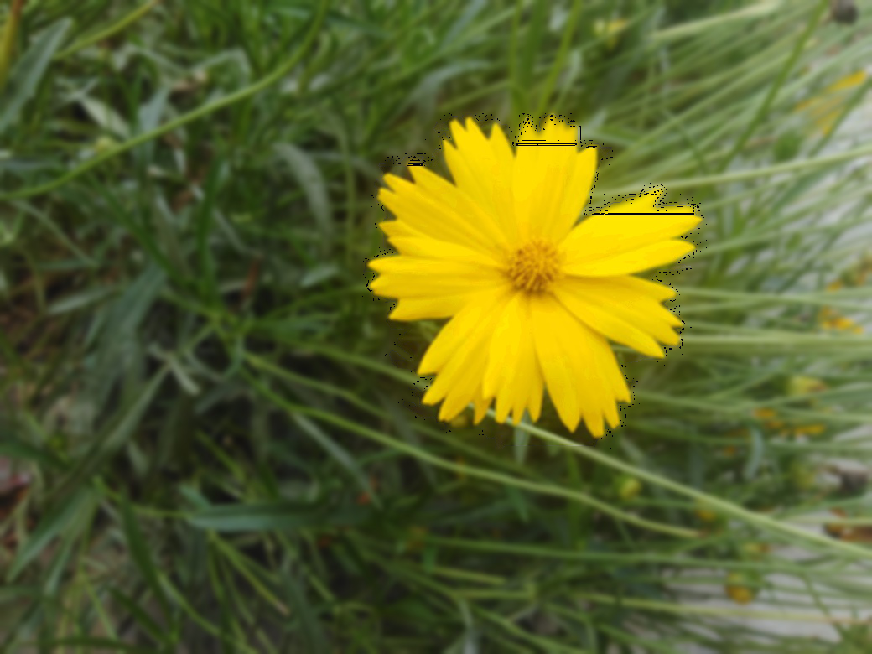

* 1. Blur Effect:

In this effect, The user can apply blur effect on any image by using the blur tool that we provide. The user just has to drag to tool on the part of the image, he wants to blur. At the end, the blurred image will be saved in the same folder.

* 1. Orginal image:



* 1. Blurred image:

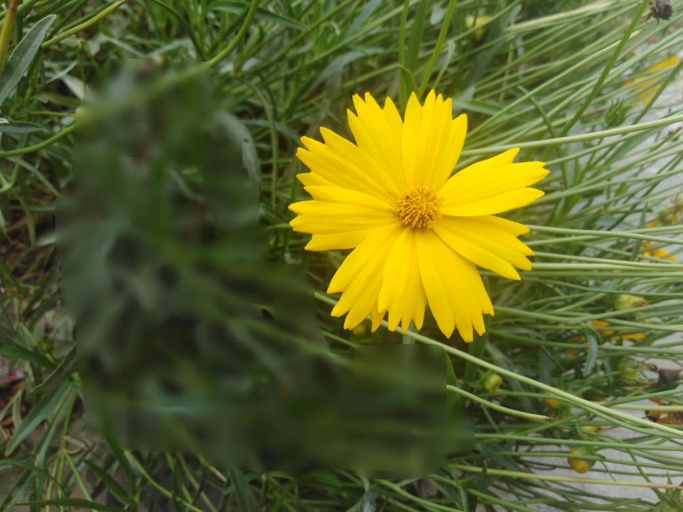

* 1. Colored Filter:

User can also apply various colored filters to their images such as Sepia, Cartoon, Black and White, Negative etc.

Original Image:

